Project Report

Titanic Survival Prediction

1. Introduction
This project explores survival prediction of Titanic passengers using supervised machine learning algorithms, which are trained on labeled data to learn the relationship between input features and the target outcome. The aim is to perform data preprocessing (handling missing values, encoding, and scaling), build and train multiple classification models (like KNN, SVM, and Logistic Regression), evaluate them using key metrics such as accuracy, precision, recall, F1-score, and ROC AUC, and select the best-performing model based on validation and test results. ROC AUC is especially useful in binary classification tasks to understand the model's discriminative ability across different threshold levels.

2. Data Exploration
Survival Rate Distribution Chart:
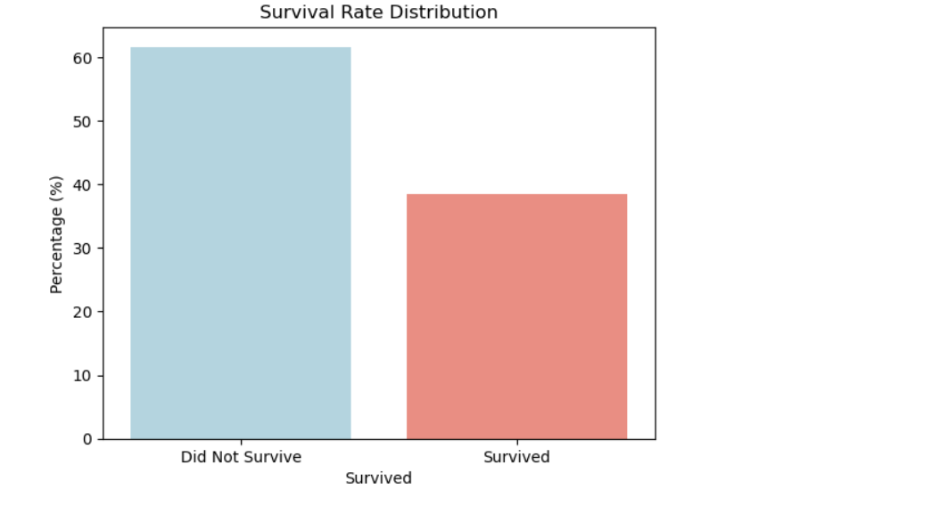
This bar chart shows that 61.8% of passengers did not survive, while only 38.2% did. This highlights the imbalance in the dataset, which informs our model evaluation strategy (e.g., prioritizing F1-score over accuracy).
The Titanic dataset is a classic example used for binary classification tasks. It consists of information such as passenger class, sex, age, number of siblings/spouses aboard, and fare paid. Data exploration helps identify data quality issues, trends, and patterns that may influence survival outcomes. Summary statistics and missing data proportions are reviewed to determine appropriate imputation strategies. The dataset includes 891 samples and 12 features. Initial exploration revealed the following missing values:
Output-
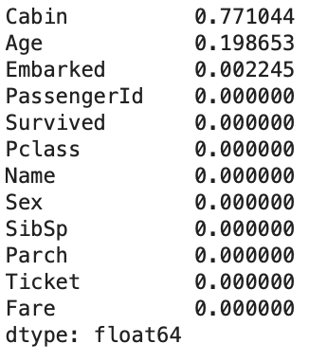
- The cabin dropped due to 77% missing values.
- Age and Embarked imputed with median and mode respectively.

3. Data Preprocessing
Data preprocessing is a crucial step in machine learning that transforms raw data into a clean and usable format. It includes handling missing values, encoding categorical variables into numerical formats, and scaling features to ensure uniformity across variables. Proper preprocessing reduces bias, improves model accuracy, and enables effective learning, especially in models like KNN and SVM that are sensitive to feature scale.
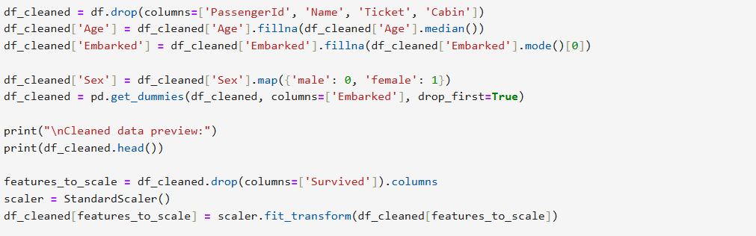
Preprocessed Data Preview:
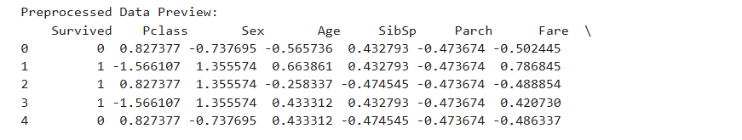
4. Correlation Matrix
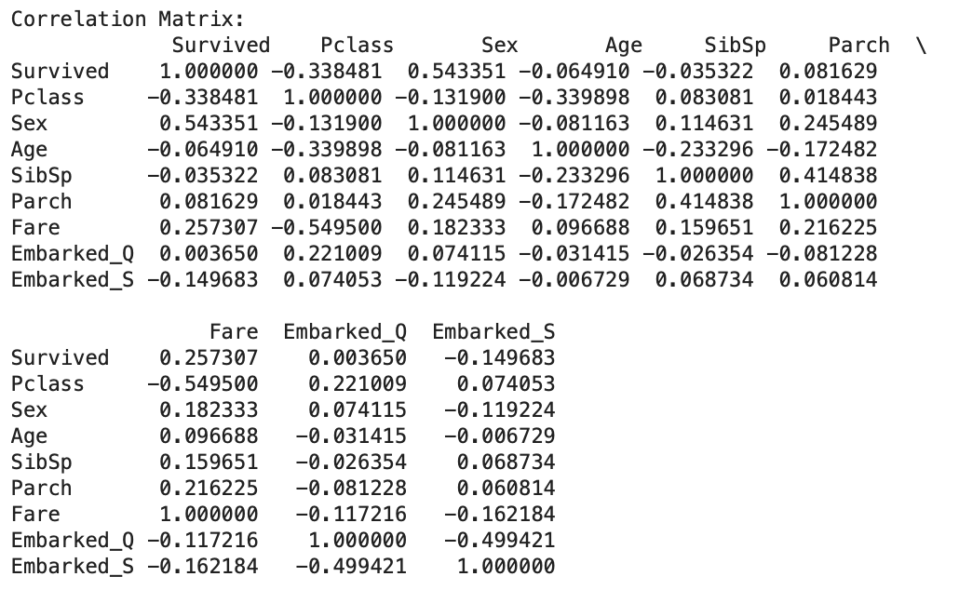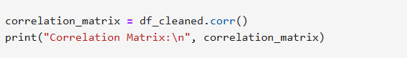

Insights:
- 'Sex' and 'Pclass' show strong correlations with survival.
- 'Fare' positively correlates with survival.

5. Data Splitting
Splitting data is a fundamental step in machine learning to evaluate a model's generalization ability. By separating the dataset into training, validation, and test subsets, we ensure that models are trained on one portion and tested on unseen data. Stratified sampling is used to maintain class distribution, which is crucial for imbalanced datasets like Titanic survival.
- Training set: Used to fit the model.
- Validation set: Used to tune hyperparameters and prevent overfitting.
- Test set: Used to evaluate final model performance.
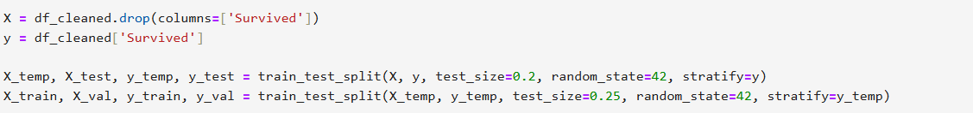
- Training: 60% (534 samples)
- Validation: 20% (178 samples)
- Testing: 20% (179 samples)

6. Model Training & Evaluation
To begin the modeling process, we trained a variety of classification algorithms on the cleaned dataset, including K-Nearest Neighbors, Decision Trees, Naive Bayes, Logistic Regression, Support Vector Machines, and even a custom-classified version of Linear Regression. Each model was trained using standard scikit-learn procedures and default settings to ensure a fair baseline comparison. The idea was not to chase perfect accuracy right away but to get a realistic sense of how well each algorithm handled the data structure, class balance, and feature relationships. This helped us establish performance benchmarks and better understand which models warranted further refinement.
Models used:
- K-Nearest Neighbors
- Decision Tree
- Naive Bayes
- Logistic Regression
- Support Vector Machine
- Linear Regression (converted to classifier)
Evaluation Metrics:
- Accuracy, Precision, Recall, F1 Score, ROC AUC

Validation Results:
Model Evaluation summary (Validation Set)
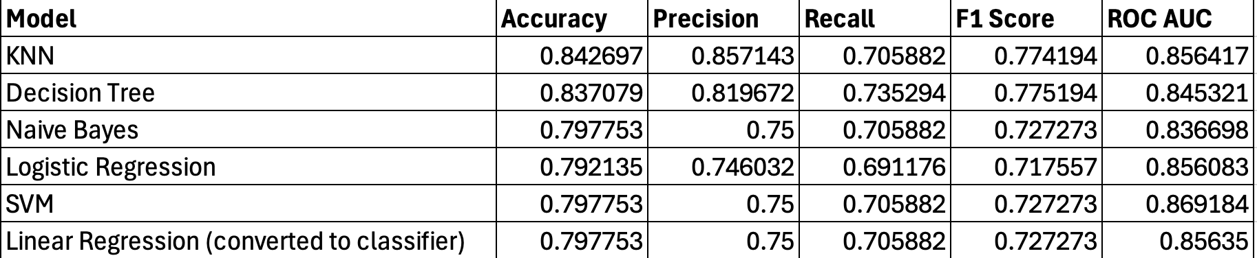
Test Set Evaluation Summary
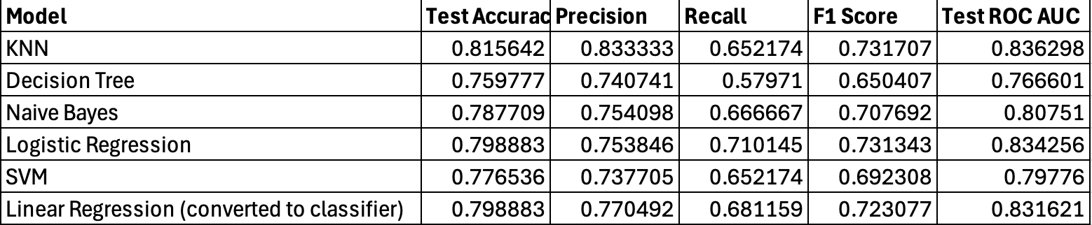
ROC Curve:
Validation Set:
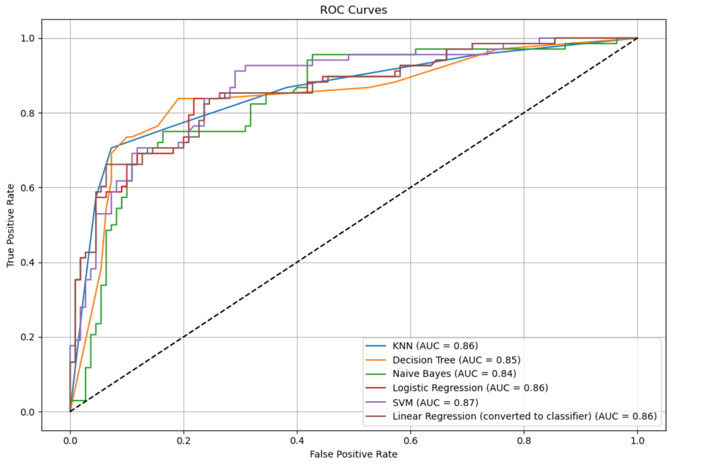
Before diving into fine-tuning the models, we began by testing several classifiers using their default parameters. This gave us a clear baseline for comparison and helped identify which models held promise straight out of the box. As shown in the ROC curve, KNN, Logistic Regression, and SVM all performed relatively well, each achieving an AUC of around 0.86–0.87. While these early results were encouraging, we knew that default settings rarely capture a model's full potential—so tuning was the logical next step

7. Hyperparameter Tuning
Once baseline performance was established, we moved on to hyperparameter tuning to unlock each model’s full potential. Using techniques like GridSearchCV and RandomizedSearchCV, we systematically explored parameter combinations to improve performance without overfitting. For example, we adjusted the number of neighbors in KNN, max depth and split criteria in Decision Trees, kernel types and regularization in SVM, and smoothing parameters for Naive Bayes. This phase wasn’t just about pushing scores higher—it was about finding the right balance between accuracy, generalizability, and model simplicity. The improvements were evident in the refined ROC curves and metrics, validating the value of careful tuning.
Used GridSearchCV with 5-fold CV to tune:
- KNN: n_neighbors, weights
- Logistic Regression: C, penalty, solver
- SVM: C, kernel, gamma
- Decision Tree: max_depth, min_samples_split
- Naive Bayes: var_smoothing
Best AUC (Validation):
- Logistic Regression: 0.86
- Decision Tree: 0.86
- KNN: 0.85
- SVM: 0.82

Validation Results:
Tuned Model Performance
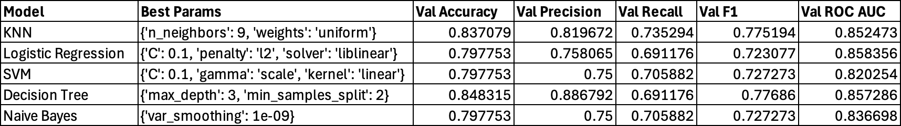

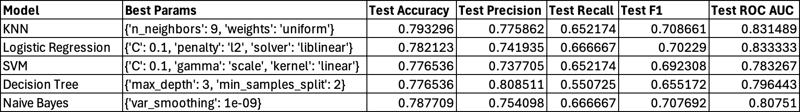

Roc Curves:
Validation ROC curves

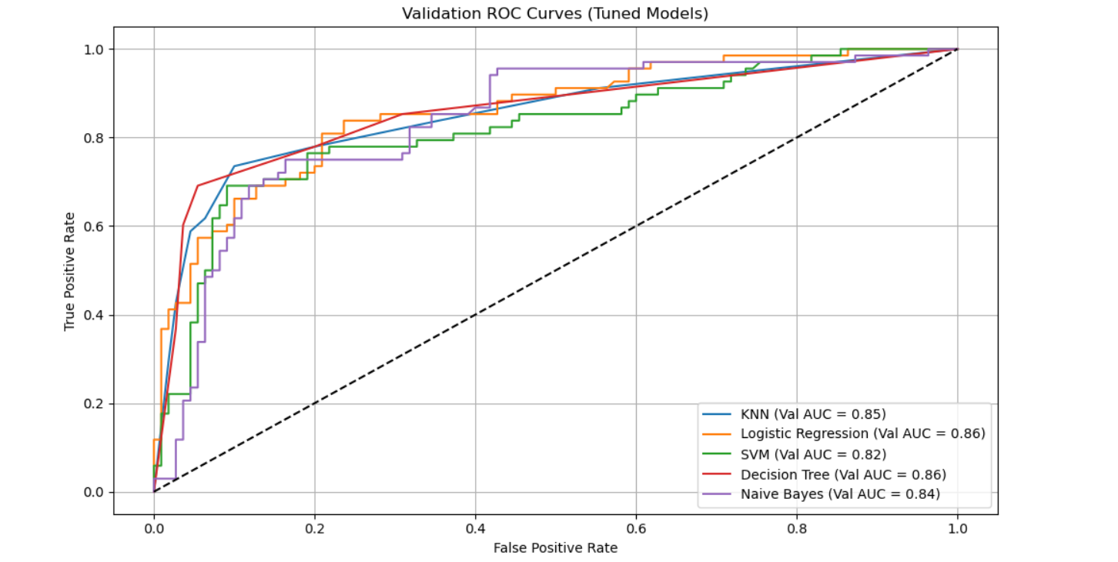

Test ROC Curves:
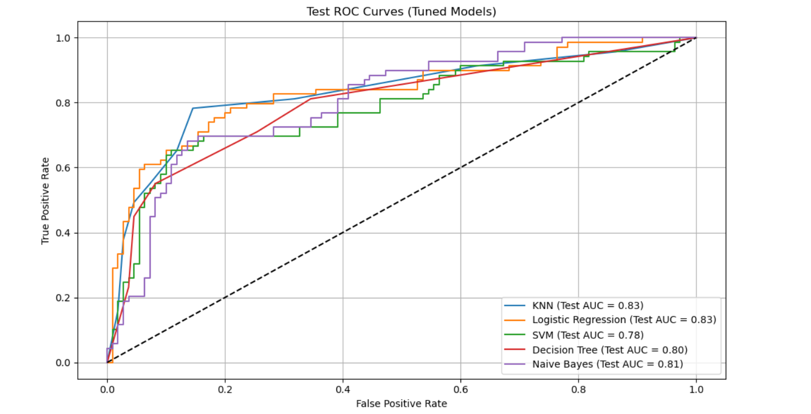

8. Final Results Table (Tuned Models)
The “Final Results Table (Tuned Models)” section summarizes the performance of the best versions of each model after hyperparameter tuning. Here's how to interpret it:
- Model: Lists the machine learning models used.
- Val AUC (Validation AUC): Measures the model's ability to distinguish between classes on the validation set. Higher is better (max = 1).
- Test AUC: The same AUC metric but evaluated on the unseen test data to assess generalization.
- Test Accuracy: The percentage of correct predictions on the test data.
Key takeaways:
- Logistic Regression and KNN showed the best combination of validation and test AUC.
- SVM had the lowest performance among the tuned models on test data, though still reasonably good.
- The test accuracy aligns closely with AUC, confirming model reliability.

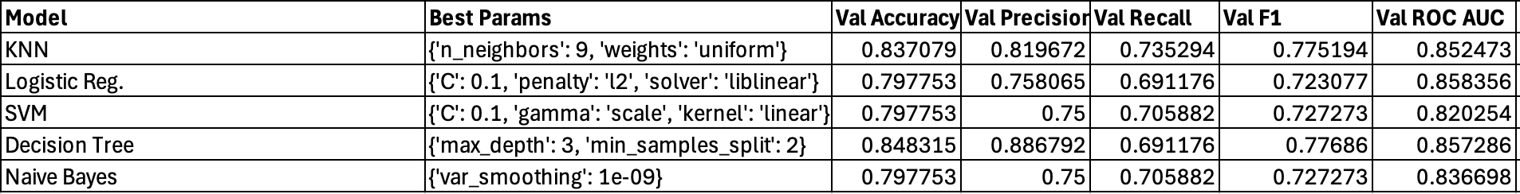
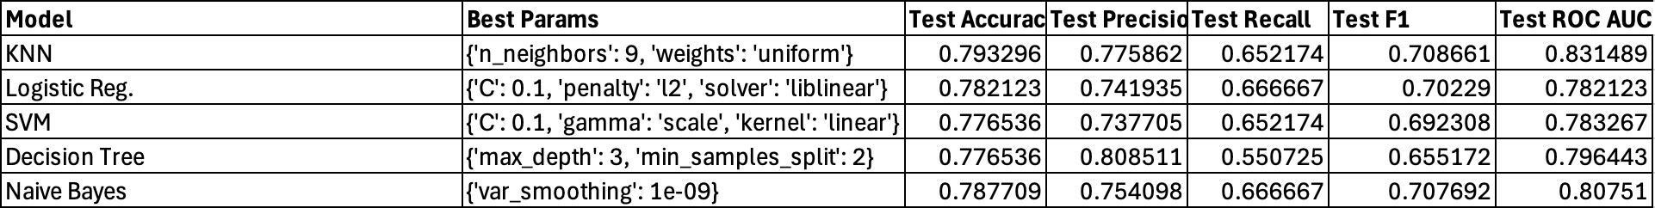

9. Conclusion
Logistic Regression and K-Nearest Neighbors (KNN) delivered the most consistent results across both validation and test datasets. Logistic Regression is valued for its simplicity, computational efficiency, and strong performance when the classes are linearly separable. It provides clear probabilistic interpretation of outputs and is well-suited for binary classification problems like survival prediction. KNN, on the other hand, is a non-parametric, instance-based learning algorithm that classifies a sample based on the majority class among its k-nearest neighbors, making it intuitive and adaptable to complex decision boundaries. Together, these models provide a balanced trade-off between interpretability and predictive strength, making them suitable for practical deployment in structured datasets like this one.
Further enhancements could include:
- Feature engineering (titles, family size)
- Ensemble techniques (Voting, Bagging)

10. Team Contributions
- Aryan: Model Generation
- Sushant: Hyper-Parameter Tuning
- Samved: Data Preprocessing, Data Cleaning, Roc curves plotting
- Awais: Model Generation

